Tab 1
Were there any questions that felt confusing or unclear? Please explain.
Overall, participants did not find any questions confusing. Only the phrasing of “the past month” could have been more specific as well as a suggestion of having a guided tour.

How did each version of the questionnaire feel to complete? Which did you prefer and why?
The responses show a clear preference for LLM-based systems over rule-based systems. One main theme is personalisation. LLMs are seen as better at understanding the user’s situation and generating more relevant questions. This makes the interaction feel more tailored and meaningful.

Another theme is natural interaction. Participants describe LLM responses as clearer, more conversational, and easier to answer, while rule-based systems feel too structured and rigid.

A third theme is emotional engagement. LLMs are perceived as more human-like and help users feel more comfortable, which is especially important in healthcare contexts. There is also recognition of the limitations of rule-based systems. They are described as predictable and easy to guess, which reduces engagement.

Finally, there is a trade-off between efficiency and user experience. Rule-based systems are seen as faster and more efficient, but LLMs are preferred because they provide a better overall experience.

Overall, users prefer LLMs because they are more personalised, natural, and emotionally engaging, even though rule-based systems are more efficient.

Quantify % of people responded based on codes -> map it with code

Please share your thoughts about the two methods. What worked well, and what could be improved?
The responses highlight several areas for improvement in the prototype. One theme is the need for clearer guidance. Users felt the overall experience was good, but additional instructions would make the process easier to follow and reduce uncertainty.

Another theme is flexibility and user control. Users prefer being able to complete the foundation assessment first and then choose which method to use, rather than being forced into the rule-based approach. Personalisation is also a key theme. While the LLM-based method is already preferred, users believe it could be further improved by adapting more closely to individual needs and situations.

There is also feedback on input design. Although questions were seen as concise, users would like the option to provide short, open-ended responses to include new or updated information.

Overall, the feedback suggests that improving guidance, increasing flexibility, enhancing personalisation, and allowing more open input would lead to a better user experience.

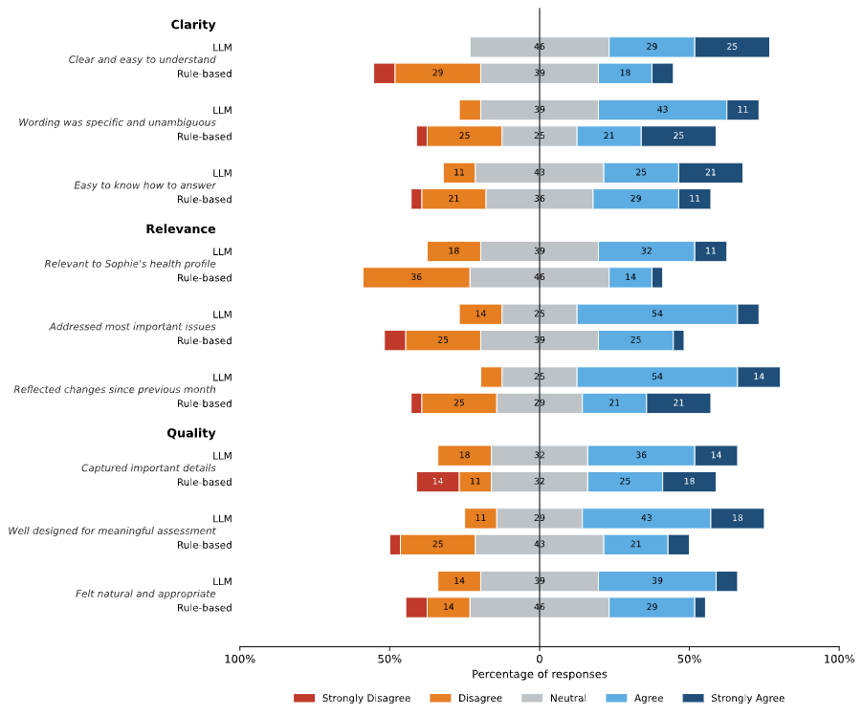

thematic_analysis -Jae

Q1 — Confusion / Clarity (open-ended)
Code | Count | Percentage | Example Response
No confusion / Clear | 27 | 69.2% | "No, both were clear." (P16)
Guidance / instructions needed | 1 | 2.6% | "Having an initial guided tour for new users would be better." (P02)
Time period wording unclear | 1 | 2.6% | "When stated 'over the past month', I'm confused how long I should check." (P04)
LLM questions were too long | 1 | 2.6% | "LLM based questions were lengthier." (P27)
Not personalised enough (both) | 1 | 2.6% | "None of the questions were confusing but the questions are not personalised enough in both sets." (P26)

Q2 — Questionnaire Preference: Thematic Analysis (n=39)
Theme | Count | Percentage | Representative Quote
No strong preference / Both OK | 11 | 28.2% | "Both were easy to complete; I felt they were quite similar." (P33)
Personalisation / Relevance | 8 | 20.5% | "The LLM-based version felt more specific and better tailored to my personal situation." (P23)
Longitudinal awareness | 4 | 10.3% | "The LLM presented questions which linked back to my Month 1 questions." (P16)
Simplicity / Transparency (Rule) | 4 | 10.3% | "I prefer the rule-based approach as it took into consideration the previous month's state, so evaluation was more transparent." (P38)
Natural / Conversational | 3 | 7.7% | "LLM feels more human-like and uses language that makes users feel more comfortable." (P05)
Brevity / Efficiency (LLM) | 2 | 5.1% | "LLM was straight to the point, less questions meant less effort especially for someone experiencing mental health issues." (P22)

Q3 — Improvement Suggestions: Thematic Analysis (n=39)
Theme | Count | Percentage | Representative Quote
More personalisation in LLM | 3 | 7.7% | "The LLM one could have some other questions in different situations, not only on class." (P36)
Better guidance / instructions | 2 | 5.1% | "Additional instructions would make the process easier to follow." (P02)
User control / flexibility | 1 | 2.6% | "The prototype should allow me to complete the foundation assessment and then choose which method to use." (P03)
Short open-ended input option | 1 | 2.6% | "Some kind of short answer to help input new or updated information would be helpful." (P11)
UI/UX improvements | 1 | 2.6% | "The side by side page was a bit hard to navigate." (P33)

